***Department of Computer Science***

***GC University, Faisalabad***

# LAB MANUAL

# FOR

# INTRODUCTION TO

# COMPUTER

**PROGRAM NO. 1**

***Aim: - To study Microsoft word***

## **What is a Microsoft -word?**

Word is a word - processor, which is marketed by a company named Microsoft Word 97 is the most full - featured word processing program is used today. Word is one of the most popular word processing software in the world. It is normally sold as part of total office automation software called Microsoft Office.

**A** **word processor therefore is a computer - based program that is:**

* Is used to type text
* Corrects spellings and grammatical errors
* Allow to preview the complete text before it can be printed
* Gives a variety of character styles and size to choose form

**Saving a Text:**

With the document open, choose file, save from the menu or press Ctrl + S tool bar.

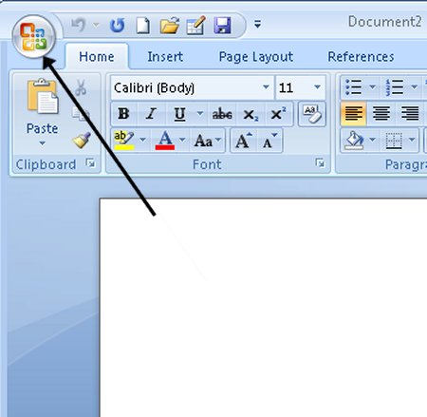

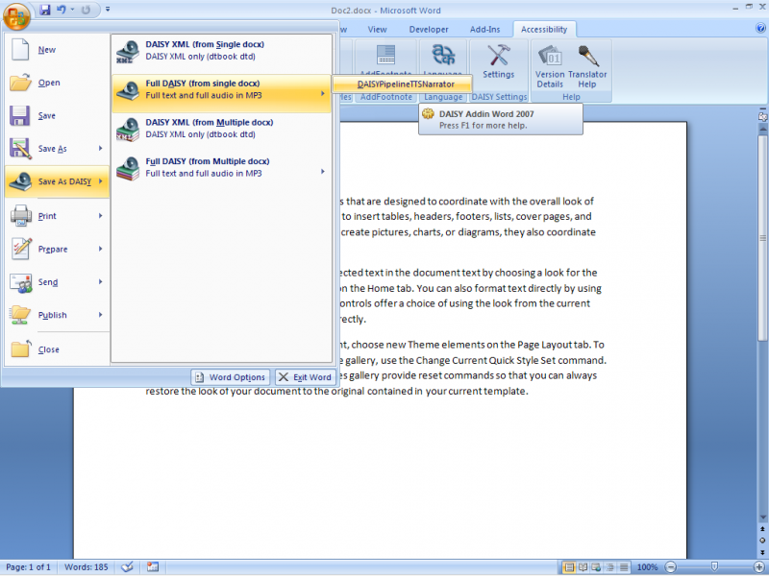

**Setting Tabs Using the Ruler:**

1. Click the tab button on the left end of the ruler to tackle through the five-tab choices.
2. Click the ruler to set the tab stops - all the default tab stops to the left of the new tabs are deleted.
3. Drag the tab - stop marker on the ruler to change the tab position.
4. Drag the tab - stop marker off the ruler to remove the tab stop.

**Aligning text vertically:**

Click the page that contains text you want to align.

Choose File > Page Setup > Layout and choose Top, Center, Justified, or Bottom from Vertically Alignment drop - down list.

**Formatting a text:**

***B I* U**

The simplest way to change the way your text looks is to use Bold, Italics, Underline button on the formatting tool bar. To apply these, just click the button you want your text to be formatted into.

**Left Alignment**: Text is placed with first letter of every line matching the left side of page.

**Justify**: Both left and right side smooth.

**Right Alignment:** Text is placed with last letter of every line matching the right side of the page.

**Changing the case of text:**

Text case refers to whether the characters are capital letters. All lower-case letters, or combination of two.

**Sentence case** : Converts selection to small letters but for the first letter of every Sentences.

**Lower case**: Converts selection to small letters.

**Upper case**: Converts selection to capital letter.

**Title case word**: Converts selection to small letters but for the first letter of every line.

**Toggle case**: Reverses selection from capital to small and vice – a-versa.

**To Setup the page:**

From the File Menu, choose page setup. Select the paper size and print orientation. To adjust margins, click the margin tab.

Click OK when you have finish setting options.

**Printing:**

You can print any office application and choose print option that fits the application.

**To Print:**

From the file menu, choose to print or press Ctrl + P. If necessary, choose different options in the print. Modify the number of copies as you want. Click all to print entire document or enter starting and ending page numbers. Click OK to begin printing.

**To Find Text:**

You can locate a spot in to edit, by searching a word. From the edit menu choose to find or press Ctrl + F. In the find and replace, type text in the find. Click find next the text in found and highlighted on the screen. To find the next word, find next again. When you will find the text you want, close the find and replace dialogue box.

**CUT, COPY AND PASTE:**

**Cut:** Start by selecting the text which is to be cut. Select CUT from the EDIT Menu.

**Copy:** Start by selecting the text which is to be copied. Select COPY from EDIT Menu.

**Paste:** Select the position of the copied text. Select PASTE from EDIT Menu.

**Checking spelling and grammar using tool bar:**

1. Click the spelling and grammar button on standard tool bar. Accept or ignore any suggested correction.
2. Click next sentence to resume checking. Click Add to add the word to the dictionary.
3. Click Change All or Ignore All to change or ignore all occur current document.
4. Click the Check Grammar check box to turn off Grammar checking.

**Preview:**

An option that allows you to see or preview the document before it can be printed. Select

* Print Preview from the file menu.

**Header:** The extra information typed on the bottom margin of every page in the document

* Select Header from the view menu.

**Footer :** The extra information typed on the bottom margin of every page in the document.

* Select Footer from the view menu.

**KEY BOARD SHORTCUTS:**

Ctrl +N: Create a new document Ctrl +O: Open a document

Ctrl +w: Close document Alt +F4: Quit word

Ctrl +z : Undo an action Ctrl +y : Redo an action

Ctrl +Shift +p: Change font size Ctrl +] : Increase font size by 1

Ctrl + [ : Decrease font size by 1 Ctrl +b : Apply bold formatting

Ctrl +u: Apply underline Ctrl + I : Apply italic formatting

Ctrl +shift +d: Double underline Ctrl +p: Print document

Ctrl +1: Single space line Ctrl+2 : Double space line

Ctrl +5: Set 1.5-line spacing Ctrl +e : Center a paragraph

Ctrl +j : Justify a paragraph Ctrl +l : Left align a paragraph

Ctrl +r : Right align a paragraph.

**PROGMNO. 2**

***Aim: - To study Microsoft excel***

**WHAT IS MICROSOFT EXCEL?**

MS-excel is a windows-based application package, which is also the member of MS-office family. It can be used to automate accounting, scientific calculation related tasks such as calculations and analysis of data. MS-excel is easily customizable. It provides a very comfortable environment and assists the user in several ways. When excel starts, worksheet opens automatically. The major elements of the excel screens are toolbars, worksheet and status bar.

**What is menu bar?**

Menu bar contains several menus which can be invoked by simply clicking on them by a mouse or by using the short cut key combinations from the keyboard. These menus provide access to different commands of excel. Menu bar displays the list of all these menu groups. The menus in excel are

|  |  |  |
| --- | --- | --- |
| **Name** | **shortcut key** | **purpose** |
| File | alt +f | commands related to file/folder |
| Edit | alt +e | command related to word processing & text editing |
| View | alt +v | commands related to page setting & Layout |
| Insert | alt +i | commands related to insertion of Various types of items |
| Format | alt +o | commands for text formatting of Cells, rows and columns |
| Tools | alt +t | contains tools like auto & spell check |
| Data | alt +d | has data processing commands |

**Important Excel functions:**

|  |  |  |
| --- | --- | --- |
| **Function** | **What it does** | **Examples** |
| sum (n1, n2) | Calculates the total of all values in Parenthesis | =sum (s2; s3) displays the total  of all the numbers in cells s2 through s3 |
| Average (n1, n2) | Calculates the avg. Of a group of values | =avg.(t2:t5) display avg. of all no. In cell t2 through t5. |
| Count (v1, v2) | Counts the no. Of cells that contain numeric values | =count (w1, w2) if every cell in this range contains a value |
| Max (n1, n2) Min (n1, n2) | Finds highest and lowest value in the list | =max (a1, a2)displays highest numeric value in list |
| Today (n1, n2) | Displays today’s date in the cell | =today () calculate the no. Of days |
| Percentage | Calculates percentage of a group of values | =c2*100/d2 displays the percentage of all the no. In cell c2 through d2. |

**Deleting a worksheet:**

1. Point to the tab of the worksheet you want to delete and right click.
2. Choose to delete from the shortcut menu.
3. Excel displays a confirmation dialog box before permanently deleting the worksheet. Click ok to delete the worksheet.

**Printing a worksheet range of data:**

1. Select one or more ranges to print. The selected ranges do not have to be continues, but they must be on the same sheet.
2. After you make your selection, pull down the file menu and choose print options.
3. In the print dialog box, choose selections from the print area.
4. Click the print preview button to confirm that the current selection is what you want to print. Adjust any other formatting options in the print preview window.
5. Click the print button.

**What is a workbook and worksheet?**

A workbook is a multi-page excel document. Each page in the workbook is called a wok sheet, and the active worksheet is displayed in the document window. At the left end of the horizontal scroll bar are sheet tabs and navigation buttons. Use the sheet tabs to move to another worksheet and the navigation buttons to scroll through the sheet tabs.

**What are worksheet components?**

Each worksheet is divided into columns, rows and cells separated by gridlines. The first column a, and the letter A appear in the column heading. The horizontal rows are numbered. Each worksheet has 256 columns (a through iv) and 65536 rows.

**Insert a worksheet?**

To insert a worksheet, go to insert menu and choose worksheet

**Delete a worksheet?**

To delete a worksheet, click on the work sheet name tab, go to edit menu and choose delete worksheet.

**Printing a document?**

To print the document, click the print button on the standard toolbar or choose print option from the file menu. A print dialog box will be displayed. Set the different items on the box, as per the print requirement and press ok.

**Moving a cell pointer?**

To move the pointer one cell to the right, left, up or down use the keyboard arrow keys.

**Data transfers between worksheet?**

1. To move or copy data from one worksheet to other, cut or copy the selection.
2. Then click the sheet tab for the sheet that you want to paste into.
3. Click in the appropriate cell and press enter to paste.

**Creating graphs and charts:**

Excel has powerful graphics and charting features. These are very useful in presentation, in decision making and in analyzing the data.

1. Open the salary worksheet.
2. Select the cells a8 till a13.
3. Hold down ctrl and select he cells h8 till h13.
4. Now we have two ranges of cells, which are required for the pie chart- the names and the net pay of the employees.
5. Click on the chart wizard on the formatting toolbar. The chart wizard appears.
6. In the chart wizard, under the standard types tab, choose pie as chart type.
7. In the sub-type section select the second figure-pie with a 3-d visual effect.
8. Click next. The next step of the chart wizard appears.
9. Click the finish button. The chart appears as an object in the salary worksheet.
10. Click the save button on the standard toolbar to save the worksheet and the chart.

**PROGRAM NO. 3**

***Aim: - To study Microsoft PowerPoint***

**WHAT IS POWER POINT?**

Power point is a complete presentation graphics package. It has the powerful features like power point wizards, toolbars and power point views to create good slides. It has all the tools required to produce a professional looking presentation, such as text handling, outlining, and drawing graphics, clipart and so on. Speaker supports, and aids help you to create truly effective presentations. It has wizard, auto layouts, and a complete set of easy to use tools assuring you to have everything you need to share your knowledge with others.

**Menus of power point:**

Menu bar has several menus which can be invoked by simply clicking on them, by using a mouse or by using a hot key combination from the keyboard. These menus provide access to different commands of power point. These commands are grouped together in menus. Menu bar displays the list of all these menu groups.

|  |  |  |
| --- | --- | --- |
| **Name** File Edit View Insert Format Tools  Slide show  Windows Help | **Shortcut key**  Alt +f Alt +e Alt +v Alt +i Alt +f Alt +t Alt +d Alt +w  Alt +h | **Purpose**  They are related to file/folder management They are related to text &and word editing They are related to page setting and layout  They are related to insertion of various types of items They text format cells, rows and column  They contain tools such as spell & auto checker They have slide show related commands Commands for document management  Various commands related to power point help |

**What is presentation?**

Power point is a good way to communicate ideas simply and effectively. For complex topics that are rich with details, such as a scientific paper or an annual report. Each presentation consists of one more pages or slides, which can contain text, bulleted lists, graphics, charts and other data types.

**Insert a new slide:**

1. To insert a new slide, you can perform any of the following tasks.
2. Insert a slide, go to insert menu and choose slide.
3. Choose a new slide button from standard tool bar.
4. From the power point startup screen, choose blank presentation.
5. If power point is already open, pull down the file menu. Choose new, select blank presentation from the general tab, and click ok.
6. Click the new button on the standard toolbar.

**Delete a new slide:**

To delete a slide, make that slides current slide and choose duplicateslidefrom the edit menu. Slide will be deleted immediately.

**Duplicate a slide:**

To duplicate a slide, make that slide current slide and choose duplicate slide from the editmenu.

**Creating master slide:**

If you want to have certain common items on all the pages without adding them individually to the slides one by one, create a master slide. The items contained in master slide will automatically become the items for all the slides.

**What are presentation graphics?**

Presentation graphics is an application software available for designing charts. You can perform any of the following tasks.

**Design characters:**

1. Arrange the matter in readable form.
2. Add pictures in the charts.
3. Change the appearance of the alphabets on the charts.
4. Print these charts.

**To display slide setup:**

In a new presentation, the slides by default have a width of 10inches, height of 7.5 inches and landscape orientation. These settings can be changed using the page setup commands. The procedure for changing the slide setup is follows:

1. Click on the main menu option.
2. Click on the page setup command, the page setup dialogue box with the default settings appear on the screen.
3. Click on the slides sized for dropdown arrow.
4. Click on letter paper (8.5*11 in).
5. Click on the portrait radio button.
6. Click on the ok button to change slide settings for every slide in your presentation. The slides will now be 10inches in height, have a width of 7.5inches and the orientation will be portrait.

**Saving a presentation:**

To save a presentation on disk, click the save button on the standard or choose save option or save as option from the file menu. Option save is to save the file with current name and save as the command to save file with some other name.

**To display a slide show:**

A presentation can be displayed on the screen by running a slide show. The slides can be advanced manually or automatically. The procedure for running the slide show is:

1. Click on the slide button. At the bottom of the slide to begin the slide show.
2. Select slide show from the view menu to display a dialog box.
3. One slide is displayed at a time each slide fills the entire screen.
4. Click on the left mouse button or press enter or press page down to move one slide forward.
5. When we reach the last slide in the presentation, power point brings us back to the slide view, or any other view that we are in.
6. Click on file menu option
7. Click on close command to close the presentation.
8. Click on exit command to exit from the power point.

**Printing a presentation:**

1. Choose file menu print to open the print dialog box.
2. In the print range area, choose the slides to be printed.
3. In the print what drop – down list, select whether to print slides, handouts, notes pages, or an outline.
4. Set other print options
5. Click ok begin printing.

**Adding a clip art to a slide:**

1. Choose to insert<picture >clipart or double- click a clip art placeholder to open the insert clip art dialog box.
2. Select the picture you want to insert and click insert menu.

**PROGRAM NO. 4**

***Aim: - To study about installation of windows***

Each version of Microsoft Windows is installed on a computer using similar steps. While there are steps in the installation process that can differ between versions of Windows, the following general steps and guidelines will help you to install Windows on your computer.

**Tip:** If you want to **upgrade to a newer version of Windows** on your computer, the steps on this page can help you with the upgrade process. The Windows installation process should recognize if you have an older version of Windows already installed on the computer and ask if you want to upgrade or perform a fresh install. The upgrade process will install the newer Windows operating system files over top the old ones and preserve your files.

The steps below are for all recent versions of Windows, including [Windows 98](https://www.computerhope.com/jargon/w/win98.htm), [Windows ME](https://www.computerhope.com/jargon/w/winme.htm), [Windows 2000](https://www.computerhope.com/jargon/w/win2000.htm), [Windows XP](https://www.computerhope.com/jargon/w/winxp.htm), [Windows Vista](https://www.computerhope.com/jargon/v/vista.htm), [Windows 7](https://www.computerhope.com/jargon/w/windows7.htm), [Windows 8](https://www.computerhope.com/jargon/w/windows8.htm), and [Windows 10](https://www.computerhope.com/jargon/w/windows-10.htm). These steps would even work for earlier versions (e.g., Windows 95) as long as you're using the disc version. The floppy diskette version is similar, but it requires additional steps.

## **Check Hardware Compatibility**

## Before installing or upgrading Windows on your computer, you should check the hardware in the computer to make sure it is compatible with that version of Windows. Microsoft provides a [Windows Compatible Products List](https://sysdev.microsoft.com/en-us/hardware/lpl/) through their website that allows you to check if the specific hardware in your computer is compatible with the chosen version of Windows.

If you find that one or more pieces of hardware in your computer are not compatible with the chosen Windows version, we recommend replacing that hardware with compatible hardware. Having compatible hardware in your computer will help ensure the Windows install or upgrade process is successful.

## **Genuine Windows CD, DVD, or USB thumb drive**

First, you will need a genuine copy of the Microsoft Windows [operating system](https://www.computerhope.com/os.htm)installation CD, DVD, or USB thumb drive. A genuine Windows [product key](https://www.computerhope.com/jargon/c/cdkey.htm) is included with the installation disc, which is required to activate Windows after installation.

## **Installing or Upgrading Windows**

To start the Windows install or upgrade process, you will need to configure your computer to boot from a CD or DVD before booting to the hard drive. Changing the boot process forces the computer to look for the Windows installation disc before trying to boot from the [hard drive](https://www.computerhope.com/jargon/h/harddriv.htm).

1. [Access the computer's BIOS setup](https://www.computerhope.com/issues/ch000192.htm).
2. Change the computer's [boot order](https://www.computerhope.com/jargon/b/bootsequ.htm). Set the CD, DVD or disc drive as the first boot device if you are trying to boot from a disc. Or, set the first boot device to your USB drive if you're trying to boot from a USB thumb drive. If the drive you want to set is not shown in the list, make sure the disc is inserted in the drive before you turn on the computer, and the BIOS should recognize it, and include it in the list.
3. Save the settings change and exit BIOS.

Once you have updated the boot order, you can begin the Windows installation process.

1. Place the Windows disc in the CD/DVD drive or USB thumb drive into the back of the computer.
2. Turn on or restart the computer. As the computer is starting up, it should see the installation disc or drive and show a message similar to **Press any key to boot from CD**. Press any key on the keyboard to have the computer boot from the Windows disc or drive.
3. The Windows install process will begin. There will be several prompts that you will need to answer. Select either **Yes** or the appropriate option to install Windows.

**Install Note:** Make sure you select the Full Install option and not the Repair or Upgrade option.

**Upgrade Note:** If you are upgrading to a newer version of Windows, select the "Upgrade" option instead of the Full Install option.

1. When asked which partition to install Windows onto, select the main partition, which is usually the C: drive or one labeled "Unaollocated partition". If upgrading Windows, select the existing installation of Windows on the hard drive.
2. You may be asked if you want to erase all contents on the hard drive, then install Windows. It is recommended that you choose this option, as it will also properly format the hard drive to allow the Windows operating system to be installed.
3. The computer may need to restart several times during the Windows install process. The restarts are normal and if prompted to restart, select the **Yes** option.
4. When the install process is nearly complete, the Windows configuration option screens are shown. On these screens, you may be asked to select the time zone you live in, your preferred language, and the name of the account you will use to access Windows. Select the appropriate options and enter the appropriate information on each configuration screen.

The Windows install process will be complete when the computer prompts you to log in with the account you just created on the configuration screens or when it loads directly into Windows.

## **Final Windows and computer configuration**

After Windows has been installed on the computer, you will need to install the [drivers](https://www.computerhope.com/jargon/d/driver.htm)and related software for the hardware in the computer. You can use the installation discs that came with the hardware, or you can [download](https://www.computerhope.com/jargon/d/download.htm) the drivers from the hardware manufacturer's website.

**Tip:** If you cannot download drivers because your network card is not working after installing Windows you can download the drivers on another computer and then copy them to a USB thumb drive and move them over to your computer.

* [How to install and update a computer driver.](https://www.computerhope.com/issues/ch000834.htm)

It is strongly recommended that you install the latest drivers for each piece of hardware.

To determine which hardware needs drivers to be installed, check the [Device Manager](https://www.computerhope.com/jargon/d/devicema.htm)and look for [exclamation mark](https://www.computerhope.com/jargon/b/bang.htm) "!" next to hardware devices. The exclamation point means drivers are needed for that device.

After installing the necessary hardware device drivers, install any software programs on the computer that you want to use.

Finally, download and install any available Windows updates. Updating Windows can help improve the performance of the operating system, the hardware in the computer, and software programs you use. It can also improve security by fixing potential security holes and flaws in Windows.

* [How to update a Microsoft Windows computer.](https://www.computerhope.com/issues/ch000545.htm)

## **Long-term maintenance of Windows**

Microsoft frequently releases new updates for Windows, so it is recommended that you check for and install available updates. Doing so will help keep Windows running better and keep your computer protected.

Also, periodically check for updated hardware device drivers from manufacturers' websites. Keeping hardware drivers updated can help the hardware devices in the computer to run at peak performance and improve compatibility with other hardware and software in the computer.

**Exercise:**

